**THE UNIVERSITY OF BUEA**

**Faculty of Science**

**Department of Computer Science**

**BACHELOR OF SCIENCE IN COMPUTER SCIENCE**

**Project Report**

**ONLINE EXAMINATION SYSTEM**

**AMATE SUBI YOLANDE**

**SC13A053**

**Supervisor**

**Dr Denis L. Nkweteyim**

**July 2018**

**CERTIFICATION**

This is to certify that this report entitled “ONLINE EXAMINATION SYSTEM” is the original work of AMATE SUBI YOLANDE with Registration Number SC13A053, student at the Department of Computer Science at the University of Buea. All borrowed ideas and materials have been duly acknowledged by means of references and citations. The report was supervised in accordance with the procedures laid down by the University of Buea. It has been read and approved by:

________________________________ _________________________

Dr Denis L. Nkweteyim Date

Project Supervisor

Head of Department of Computer Science

________________________________ __________________________

Dr Denis L. Nkweteyim Date

Head of Department of Computer Science

i

**DECLARATION**

This report has been written by me and has not received any previous academic credit at this or any other institution.

_____________________________

Amate Subi Yolande

SC13A053

Department of Computer Science

Faculty of Science

ii

**ACKNOWLEDGMENT**

Itake this opportunity to express my profound gratitude to all my university lecturers for their support and guidance throughout the course of this program. In particular, I want to thank and appreciate all lecturers of the department of Computer Science for their support and encouragement.

In a special way, I would like to thank my parents and family whose endless support and encouragement made this happen.

My thanks and appreciations also go as well to my friends, coursemates and all those who have assisted or helped me out in developing this project one way or the other.

Above all, I thank the almighty God for the grace and strength he has given me to carry on this program succesfully.

iii

**ABSTRACT**

This project Online Examination System is a Multiple Choice Questions(MCQ) based examination system that provides an easy to use online environment for both Examiners and Students to conduct and take exams. With this system, teachers can set exam for courses, and candidates can take examinations remotely, automatically served by the system from a database of questions pre-composed by the examiner or teacher.

This system aims to speed up the process of conducting examinations unlike the traditional method of conducting exams whereby students take paper-based exams on fixed schedules and teachers often have a very tedious job of correcting scripts afterwards which may even be prone to marking errors. Also, with an online examination system, students can take their exams at anytime convenient.

Also, teachers and students need not be in a formal school environment or setting to make use of this application. It is generic and open to all who wish to conduct or take exams. The system thus provides a very easy to use interface that is secure and reliable for teachers and students.

iv

**LIST OF TABLES**

**Database Tables**

Table 3.4.4.1 User…………………………………….....................14

Table 3.4.4.2 Admin………………………………….....................14

Table 3.4.4.3 Student…………………………………....................14

Table 3.4.4.4 Questions………………………………....................14

Table 3.4.4.5 Course…………………………………….................15

Table 3.4.4.6 Exam……………………………………...................15

Table 3.4.4.7 ExamQuestions…………………………...................15

Table 3.4.4.8 StudentAnswer…………………………....................15

Table 3.4.4.9 StudentExam……………………………...................15

v

**TABLE OF CONTENTS**

Certification..........................................................................................................i

Declaration...........................................................................................................ii

Acknowledgment.................................................................................................iii

Abstract................................................................................................................iv

List of Tables........................................................................................................v

**Chapter 1 INTRODUCTION**…………………………………………..........1

1.1 Background and Motivation…………………………………….......1

1.2 Aim of the Project………………………………………………......1

1.3 Boundaries to the Project……………………………………….......1

1.4 Report structure………………………………………………..........2

**Chapter 2 LITERATURE REVIEW**…………………………………..........3

2.1 Introduction……………………………………………………........ 3

2.2 Advantages of proposed system………………………………..........3

2.3 Some Features of Online Exam Systems………………………........4

2.3.1 Login…………………………………………………………....4

2.3.2 Randomization of Questions…………………………………....4

2.3.3 Portability………………………………………………….........4

2.3.4 Timer……………………………………………………............4

2.3.5 Auto-Grading……………………………………………...........4

**Chapter 3**  **ANALYSIS AND DESIGN**………………………………..............5

3.1 Problem Statement…………………………………………………....5

3.1.2 Requirements……………………………………………….........5

3.1.2.1 Functional Requirements…………………………...........5

3.1.2.2 Non-Functional Requirements……………………...........6

3.2 Research Questions……………………………………………...........7

vi

3.3 Methodology………………………………………………….........................8

3.4 Design…………………………………………………………...........9

3.4.1 Context Diagram……………………………………............9

3.4.2 Flow Diagram………………………………………….......10

3.4.3 Use Case Diagram…………………………………............11

3.4.4 Database Structure…………………………………............12

**Chapter 4**  **RESULTS AND DISCUSSIONS**…………………………...........17

4.1 Implementation ……………………………………………...........................17

4.2 Discussion…………………………………………………............................19

**Chapter 5 CONCLUSION**……………………………………………............20

**REFERENCES**.....................................................................................................21

vii

**1 - INTRODUCTION**

This project “Online Examination System” aims to provide a platform via the internet where teachers can compose multiple choice examinations with limited time and students can take these exams. When the exam is over or the given time is expired, the system automatically stops, marks the exam and computes the score of the student instantly. This system will greatly assist the examiners and teachers in reducing the work of leading exams, checking answer sheets, and producing the results.

**1.1 BACKGROUND AND MOTIVATION FOR THIS PROJECT**

It is known that coordinating or taking an examination can be a very tedious task for both the teachers and students. Traditionally, the process is done physically by teachers having to print exams on paper, invigilate students at a given location, collect answer sheets, mark, produce and compile results within a limited time. Imagine all of these for a very large class size. On the other hand, students are expected to move to examination centers to take exams, wait sometime for the hall to be set so exams could begin, it could be tiring and exhausting as well.

Now, the online examination systems come in to resolve the issues faced in the traditional examination process by primarily reducing cost associated with printing, personnel and distribution of results. It also eliminates the lengthy process from administration of exams to collection and analysis of results and giving feedback.

**1.2 Aim of the Project**

The main aim of this project is to change the current manual system of conducting tests and exams, into a computerized one. This project would be particularly very useful for educational institutes where regular evaluation of students is required.

**1.3 Boundaries to the project**

Initially, I intended to make this project specific so as to meet just university requirements, but later on realised that this was going to be very limiting in terms of “who can or should use the 1

system” and also a more complex task especially given that there is no complete knowledge of the entire university system and subsystem as of now. So I thought trying to make it more geric would be a better option as it would not just be usable by many, but also enable quizzing or examining in an informal educational setting. I believe that making the system more generalized gives everyone the chance and the stage to set and take quizzes or exams in whatever milieu and for whatever reasons or motives.

**1.4 Report Structure**

This report is split into five chapters and it begins by introducing the project, presenting a background knowledge and motivation, aim and scope of the project. The second chapter presents a review of literature of past research work on Online examination systems. The third chapter further analysis the project, bringing out the intended problem, methodologies used in gathering and analysing the information and proposed design strategies. The fourth chapter mainly discusses project implementation, results, evaluation and outcomes of the work done.

Finally, a conclusion and direction for further research.

2

**2 - LITERATURE REVIEW**

**2.1 Introduction**

It is no news that online examinations are now becoming a much more preferred model to the traditional examination methods which is usually associated with issues such as that of high costs for acquiring examination resources, examination malpractices, venue capacities, delay in compilation and release of exam results and so on. Thus, the adoption of this new examination practice entails that users, administrative personnel and institutions get to adapt and acquaint themselves to the online examination practice. Online examination practices bring in a bunch of benefits such as flexibility, ease, convenience and in all security [[1]](https://paperpile.com/c/r5Tq7a/U5EL).

**2.2 Advantages of Proposed System**

This proposed system for online education will help promote distance learning and also bridge the gap between the learner and the instructor, this happening to be a perfect approach for mass education around the globe. This system will enable students or persons to take exams from any part of the world at any day and time with just access to internet connectivity [[2]](https://paperpile.com/c/r5Tq7a/5ff2).

One major point of concern that the proposed system addresses appropriately is the aspect of safety and security under which examinations are conducted online so as to avoid or eliminate cheating and other negative vices during examinations hence leading to fairness. Another advantage of the new proposed system is correctness of results.

A fully automated examination system like this one reduces the workload on teachers, allowing them to focus more on the teaching rather than evaluation. Also, the institution saves a lot in terms of finance as they do not need to spend on printing material, hiring staff for supervision of exams and other resources. This also saves a lot of time and energy which could be invested into something more useful [[3]](https://paperpile.com/c/r5Tq7a/ESRj).

3

**2.3 Some features of an online examination system**

Thissection presents some features that an online examination system should posses in order to meet standards and requirements. Some of them are:

**2.3.1 Login**

The login operation is required to access the system. The entered login information is checked across a database, if valid, an authorization is granted else authorization is being denied. This feature is meant to enhance security by allowing only authorized parties have access to the system.

**2.3.2 Randomization of questions**

As students login and request for exam questions, the questions are served in a random order by the system for each student taking that same exam. As such, no two students taking an exam will have the same order of questions. This is purposely aimed at eliminating cheating during examinations.

**2.3.3 Portability**

This feature wants to ensure that the online examination system can work on a range of platforms or operating environments without troubles [[4]](https://paperpile.com/c/r5Tq7a/wADB).

**2.3.4 Timer**

The system should have a timer to regulate the examination time for each each student taking an exam.

**2.3.5 Auto-Grading**

As soon as the examination is completed, the system automatically calculates the score by checking student response or answers against the correct one found in the answerbank [[5]](https://paperpile.com/c/r5Tq7a/jS9M).

4

**3 - ANALYSIS AND DESIGN**

**3.1 Problem Statement**

Theproject requires to build an online examination system that would enable teachers or examiners to set multiple choice based exams online and students can remotely take these tests or exams by answering exam questions set by a teacher. The system should be such that the student selects a course to be tested on and the system selects an examination for the student to do. Scores should be automatically calculated and sent immediately to students upon completion of exams.

Some major functionality that the system should have includes the following:

- An easy to use web user interface to manage the overall functioning of the system

- Login capability to regulate and manage access into the system.

- Ability for administrator to set exams for courses.

- Ability for students to write exams within stipulated time by administrator.

- Ability for system to automatically calculate scores upon completion of examinations

- Ability for the user to view the scores .

**3.1.2 Requirements**

Following the main requirements identified in the problem statement we classify them in the

functional and non-functional requirements. They are discussed below.

**3.1.2.1 Functional Requirements**

These are requirements that the online examination system must satisfy in order to operate properly. They are being classified into 2 main modules:

**Teacher module:**

The teacher logs in, creates courses and sets examinations for candidates. The teacher can update exams, set time for exams, view student marks and details.

5

**Student module:**

Enables the student to login to the system and take examinations for courses after which they get instant feedback. Students too can view their past records.

**As Teacher/Admin**

- Logging into the system

- Creating/Deleting/Editing exams

- Set time duration for each exam

- View student record/details

-Logout

**As Student**

- Logging into the system

- Select course to take exams for

- Answer exam questions for selected course

- Submit exams upon completion

- Get/view score for any exam taken

- View all exams taken

- Log out of the system

**Database Requirements**

The database should store all user activities and information like username and password, courses, exams and results. It should be well defined and structured with good design to avoid redundancy.

6

**3.1.2.2 Non-functional Requirements**

**Usability:**

The interface should be user friendly with all options clearly presented to the user. The system too should be fairly easy for the user to operate with minimal effort required.

**Performance:**

Scores should be properly calculated after the exams. The system should be able to support multiple users at a given time.

**Availability:**

The system should be readily available for use at anytime.

**Security and safety:**

Every user can only gain access into the system by logging in. As such, only those with valid permissions are granted access. A randomised set of questions may be provided for different students at a given time so as to avoid cheating.

**Portability:**

The system should be easily transported or moved from one operating environment onto another.

**3.2 Research Questions**

Based on problem definition above, we identify some critical aspects and create a few research questions to cover the problem.

**RQ1.** How should data be exchanged between the clients and the server?

**RQ2.** What technologies are best fit for implementation of the online examination system?

**RQ3**. Would teachers and students find the web based platform easier to use?

7

**3.3 Methodology**

Some development methodologies that could be considered in this project includes the waterfall model, agile model, iterative model, V-model. Amongst all of these various alternatives, the system will be implemented using the agile methodology for a number of benefits outlined below;

- It allows for changes to be made to the system after initial planning, thus making it easy to add new features and continuously update and modify the system which may be as a result of changing requirements.

- It focus on a rapid life cycle development and allows a product to be delivered within a limited space of time.

- Constant testing after each phase ensures that bugs always get caught.

**Programming Tools**

This section addresses some different programming languages and tools that is being used for developing this project. For the scope of this project, we make use of mainly PHP and Mysql. An Apache server is also used in developing this system

**PHP**

Given that the project online exam system is web based, PHP happens to be a very useful tool as it is a server side scripting language used to create dynamic web pages that can interact with databases. It is beneficial for the following reasons;

- Cross-platform compatibility as it can be run on various platforms

- Easy to use

- Fast and reliable

- It is compatible with most servers and databases.

- It is free(open source) and has a powerful library support

**Mysql**

Mysql is an open source relational database management system that is easy to use, fast, reliable

8

and suitable for applications of any size due to its ability to scale. Mysql uses SQL, a Structured Query language which is popular and widely used for storing, accessing and managing content in a database. It is free and has a stable release.

**HTML**

Hypertext Markup Language is a standard markup language and is used to create web page content. In this project, html is embedded within the php to structure web page contents.

**CSS**

Cascading Style sheet is a language used for describing the presentation and display of HTML elements. It is used for overall styling of the application.

**3.4 Design**

The purpose of a design is to help ease the implementation of a system. Thus, it is required to have a very clear and concise project design as it would serve as a guide throughout the implementation phase.

There are 2 main categories of users of the system:

- Teacher/Administrator

- Student

**3.4.1 Context diagram**

This diagram depicts a high level view of the system, showing the various entities that interact with it.

9

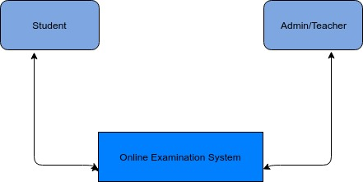

Figure 3.1 Context diagram for online examination system.

**3.4.2 Flow Diagram**

This diagram represents the flow of data through the online examination system, so as to visualize the entire flow of activities within the system.

10

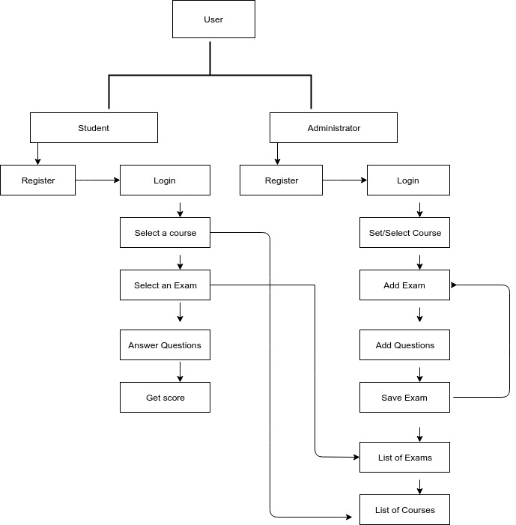

Figure 3.2 Data Flow Diagram for Online Exam System

**3.4.3 Use Case Diagram**

11

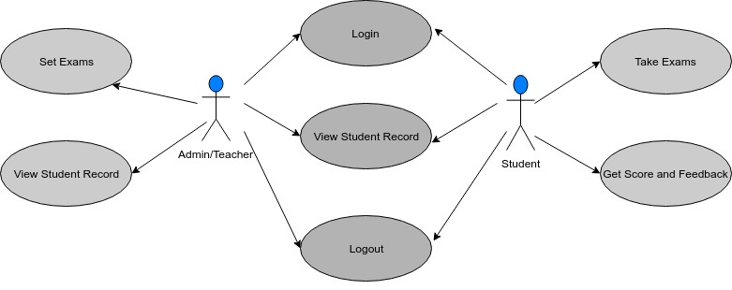

Figure 3.3 Use Case Diagram depicting different use scenarios for the Exam System

**3.4.4 Database Structure**

The system would make extensive use of a MySQL database management system for storing and retrieving data as it happens to be a free(open source) tool for development. It is also well known for its powerful and effective storing and querying capabilities to and from a database.

1

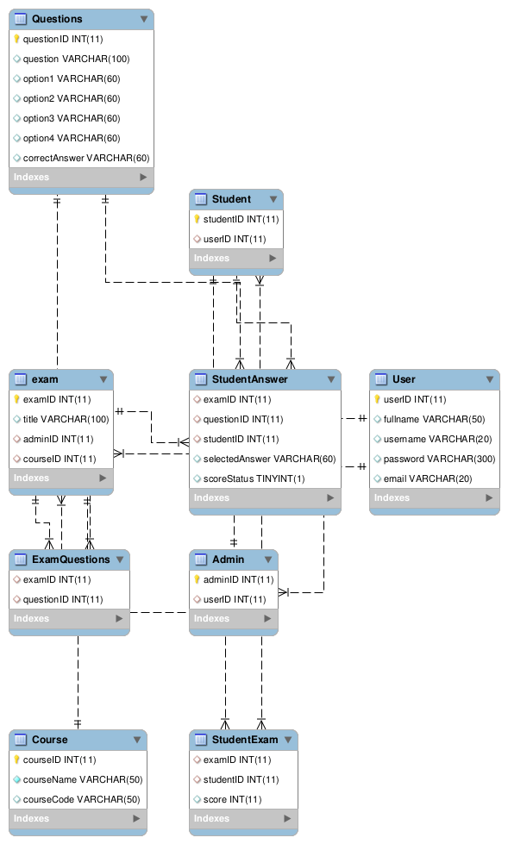

Figure 3.4 Database Model Diagram

13

The database would as well make use of the following tables.

**3.4.4.1 User**

|  |  |  |
| --- | --- | --- |
| **Field** | **Data type** | **Description** |
| userID | integer | Primary key |
| fullname | varchar | Not Null |
| password | varchar | Not Null |
| email | varchar | opt |

**3.4.4.2 Admin**

|  |  |  |
| --- | --- | --- |
| **Field** | **Data type** | **Description** |
| adminID | integer | Primary key |
| userID | integer | Foreign key |

**3.4.4.3 Student**

|  |  |  |
| --- | --- | --- |
| **Field** | **Data type** | **Description** |
| studentID | integer | Primary key |
| userID | integer | Foreign key |

**3.4.4.4 Questions(**exam questions and the right answer**)**

|  |  |  |
| --- | --- | --- |
| **Field Name** | **Data Type** | **Description** |
| questionID | integer | Primary key |
| question | varchar | Not Null |
| option1 | varchar | Not Null |
| option2 | varchar | Not Null |

14

|  |  |  |
| --- | --- | --- |
| option3 | varchar | Not Null |
| option4 | varchar | Not Null |
| correctAnswer | varchar | Not Null |

**3.4.4.5 Course**

|  |  |  |
| --- | --- | --- |
| **Field** | **Data type** | **Description** |
| courseID | integer | Primary key |
| courseName | varchar | Not Null |
| examID | varchar | Foreign key |
| adminID | integer | Foreign key |

**3.4.4.6 Exam**

|  |  |  |
| --- | --- | --- |
| **Field** | **Data type** | **Description** |
| examID | integer | Primary key |
| title | varchar | Not Null |
| courseID | integer | Foreign key |
| adminID | integer | Foreign key |

**3.4.4.7 ExamQuestions(**link between the exam and the questions taken**)**

|  |  |  |
| --- | --- | --- |
| **Field** | **Data type** | **Description** |
| examID | integer | Foreign Key |
| questionID | integer | Foreign key |

15

**3.4.4.8 StudentAnswer(** validates the selected response for any question**)**

|  |  |  |
| --- | --- | --- |
| **Field Name** | **Data Type** | **Description** |
| examID | integer | Foreign key |
| questionID | integer | Foreign key |
| studentID | integer | Foreign key |
| selectedAnwer | varchar |  |
| score_status | boolean |  |

**3.4.4.9 Student-Exam(** links student and the exam taken**)**

|  |  |  |
| --- | --- | --- |
| **Field Name** | **Data Type** | **Description** |
| examID | unsigned integer | Foreign Key |
| studentID | unsigned integer | Foreign Key |
| score | int |  |

16

**4- RESULTS AND DISCUSSION**

**4.1 Implementation Results**

**Login Page**

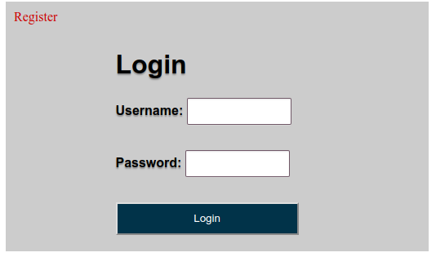

**Admin Dashboard**

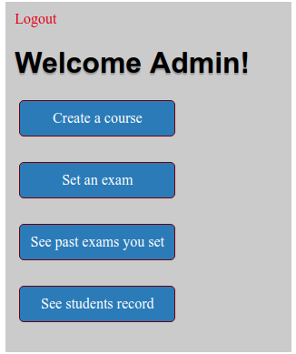

17

**Set Course Page**

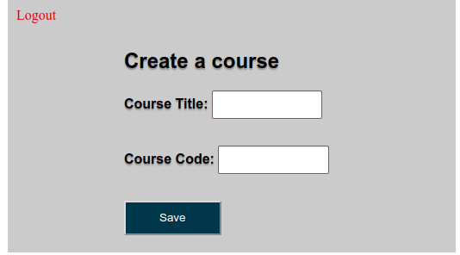

**Set Exam Page**

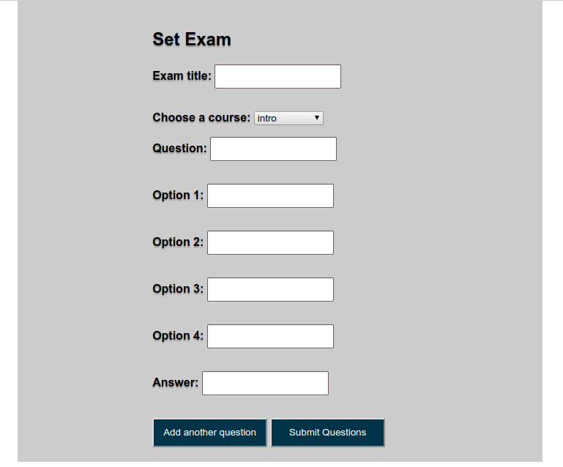

18

**Student Dashboard**

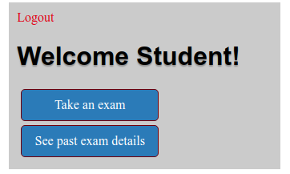

**4.2 Discussion**

To begin, the user is expected to login or register if new to the system so as to gain access. During the registration, the user is to select a mode of operation, that is, to operate either as a teacher or as a student.

If a user is operating as an administrator, then from registration or login page will be redirected to the admin dashboard. If operating as a student, the user will be directed to the student dashboard page.

As an administrator, user is expected to set exams for courses, as all exams must belong to a course. All exams must be in multiple choice format. If you already have exams set, then you can see details of your exams and students who took your exams.

As a student, you can take exams for a course by first selecting a course from course list, selecting an exam for the chosen course and then begin answering the exam questions and submit when done.

19

**5- CONCLUSION**

This system was developed using PHP and MySQL, with HTML and CSS for structuring and styling. Overall, the system performs login and registration functionalities allowing administrators/teachers to create courses and set exams. Due to time limitations working on this project, certain features such as timing and auto-grading have not yet been implemented as such, the system is not fully functional yet. That notwithstanding, the system has a well structured database design and implementation with sample queries that could ease the implementation of additional features to the project.

**Future Prospects:**

Also if time and resource constraints are eliminated, this system can be adapted to a full-fledged Knowledge Portal, wherein a personalized environment for each user who are a part of it can be created.

20

**REFERENCES**

[1] [N. A. Omoregbe, A. A. Azeta, A. O. Adewumi, and A. O. Oluwafunmilola, “IMPLEMENTING AN ONLINE EXAMINATION SYSTEM,” presented at the Proceedings of 8th International Conference of Education, Research and Innovation (ICERI2015), Seville, Spain, 2015.](http://paperpile.com/b/r5Tq7a/U5EL)

[2] [O. A. Abass, S. A. Olajide, and B. O. Samuel, “Development of Web-Based Examination System Using Open Source Programming Model,” *Turkish Online Journal of Distance Education*, vol. 18, no. 2, pp. 30–42, Apr. 2017.](http://paperpile.com/b/r5Tq7a/5ff2)

[3] [B. Shubham, S. Chaudhari, and J. Golguri, “Web Based Online Examination System,” *Issuu*, Apr-2017. [](http://paperpile.com/b/r5Tq7a/ESRj)Online]. Available: https://issuu.com/grdjournals/docs/grdjev02i050057[.](http://paperpile.com/b/r5Tq7a/ESRj)

[4] [Y. Mohammed and H. Maysam, “Construction of an Online Examination System with Resumption and Randomization Capabilities,” Apr-2015.](http://paperpile.com/b/r5Tq7a/wADB)

[5] [P. Ana and T. P. Bukie, “DESIGN AND IMPLEMENTATION OF ONLINE EXAMINATION ADMINISTRATION SYSTEM FOR UNIVERSITIES,” *Global Journal of Mathematical Sciences*, vol. 12, no. 0, pp. 39–51, Jan. 2014.](http://paperpile.com/b/r5Tq7a/jS9M)

21